**Ideation Phase Brainstorm&Idea Prioritization Template**

|  |  |
| --- | --- |
| Date | 9 November 2022 |
| Team ID | PNT2022TMI46219 |
| Project Name | Project – Natural Disaster Intensity Analysis and Classification Using Artificial Intelligence |
| Maximum Marks | 4 Marks |

# Brainstorm & Idea Prioritization Template:

Brainstorming provides a free and open environment that encourages everyone within a team to participate in the creative thinking process that leads to problem solving. Prioritizing volume over value, out-of-the-box ideas are welcome and built upon, and all participants are encouraged to collaborate, helping each other develop a rich amount of creative solutions.

Use this template in your own brainstorming sessions so your team can unleash their imagination and start shaping concepts even if you're not sitting in the same room.

# Brainstorm & Idea Prioritization for “Natural Disaster Intensity Analysis and Classification Using Artificial Intelligence”:

**Reference**: <https://tinyurl.com/muralbrainstorm>

**Step-1: Team Gathering, Collaboration and Select the Problem Statement**



**Brainstorm**

& **idea prioritization**

Use this template in your own brainstorming sessions so your team can unleash their imagination and start shaping concepts even if you're not sitting in the same room.

(9 10 minutes to prepare

lil 1 hour to collaborate

1 2-8 peoplerecommended

**0**

**Before you collaborate**

A little bit of preparation goes a long way with this session. Here's what you need to do to get going.

010 minutes

0 Team gathering

Definewho should participate in the session and sendtin

invite. Share relevant infOl'mation or pre-work ahead

(!] 5etthegoal

Think abol..lt the problem you'llbe focusing on solving in the brainstOfming session.



Open article

**0**

**Define your problem statement**

What problem are you trying to solve? Frame your problem as a How Might We statement This will be the focus of your brainstorm.

0 5 minutes

How to over comethe problem of classifrying the Natural Disaster ?

**e**

Key rules of brainstorming

To run 11n smooth and productive session

0 Stay in topic.

0 Defer judgment.

Go for volume.

*-:<v-* Encourage wild ideas Listen to others.

@ tf possible. be visunl.

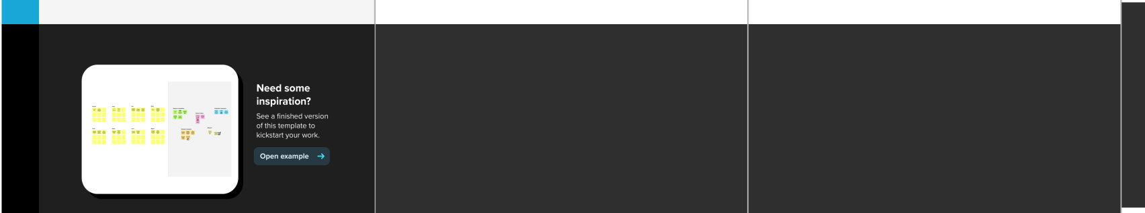

Share template feedback

**Step-2: Brainstorm, Idea Listing and Grouping**

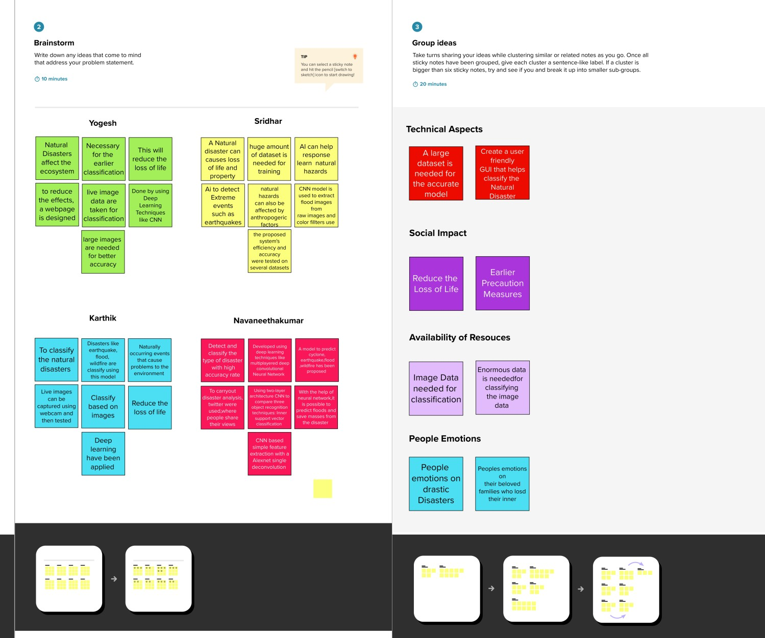

**Step-3: Idea Prioritization**

